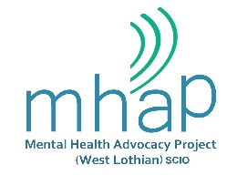

MENTAL HEALTH ADVOCACY PROJECT
(West Lothian) SCIO

Personal Specification of Advocacy Worker (Individual)

CRITERIA | ESSENTIAL | DESIRABLE
Personal Skills

Excellent communication skills, both verbally and in writing, to communicate with people at all levels of Project and outside agencies.

Ability to work autonomously, creatively and flexibly and enjoy
problem solving.

Work in an empathetic and non-judgmental way.

Ability to assess and prioritise needs and respond accordingly.

Approachable and enthusiastic.

Commitment to teamwork, negotiation and sharing.

Commitment to equality and justice.

Experience/Knowledge

Computer literate and good IT skills.

Experience of working within a small team.

Excellent organisational skills.

Understanding of record keeping, and ability to maintain, confidentiality and data protection.

Knowledge and understanding of mental health, mental illness, substance misuse and independent advocacy.

Ability to work on own initiative and to meet deadlines without supervision.

A relevant qualification.

Managing a caseload.

Experience of outreach work.

Other

Own transport and a full driving licence.

