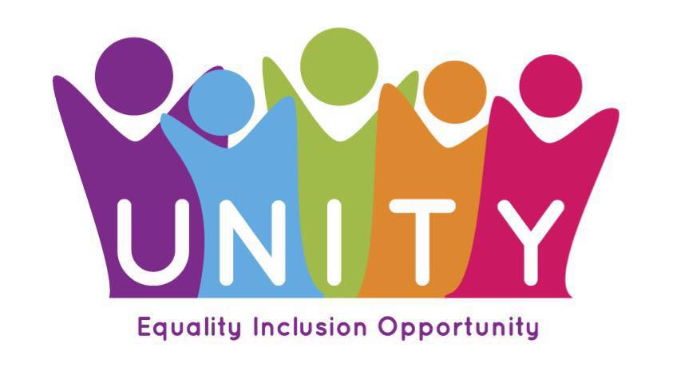
Our Mission
UNITY believes in fair and inclusive communities where everyone is valued and has opportunities to fulfil their potential.

Our Aims
Equality, Inclusion and Opportunity

Our core values
We show our values through the way we engage with others – our colleagues, our partners, those who use our services and the communities in which we work.

These are OUR values. We ALL work hard to uphold them.

Equality
We welcome everyone, and everyone will be treated equally.

Inclusion
We all flourish when we feel included and involved. We do our best work by recognising the skills and contributions of everyone – valued people do great things!

Honesty
We will always be honest in the way we work and communicate with others. If we get it wrong, we will say so, and do better by learning for next time.

Fairness
We will always aim to make decisions that are fair and just.

Bravery
Sometimes we have to try things without knowing how or if it will work out. We will always give something a go if we think we can make a positive impact.

Respect
We will respect ourselves and each other. This is important for us as a team, but also helps us to build great relationships with others and make the best contribution we can.

Kindness
Because it’s important and makes such a difference.

We are Unity. And these are our values

