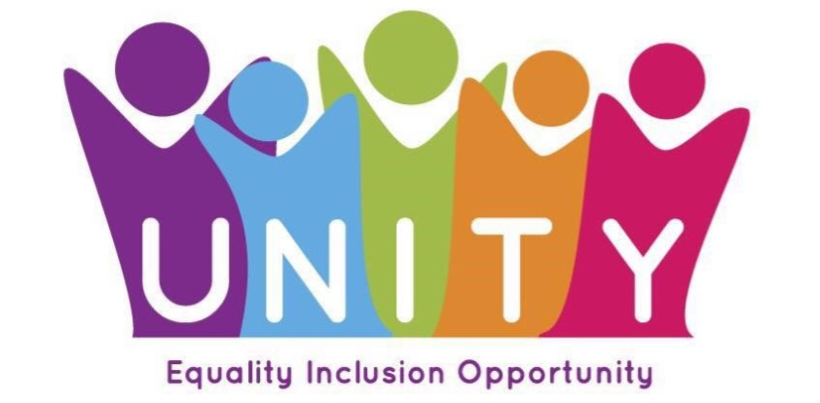

About Unity
We are Unity (formerly Unity Enterprise). We are a Scottish Charity and Social Enterprise founded in 1989. Over the years we have provided a variety of support services to people who are vulnerable, disadvantaged or a risk of exclusion across the West of Scotland.
We believe in fair and inclusive communities where everyone is valued and has opportunities to fulfil their potential. This takes many forms, and we are always looking for new ways to support our fellow citizens and widen our impact.
We provide phone, face to face and group support to Carers, young and old, across North and South Ayrshire as well as providing short breaks and trips. We also deliver workshops and information sessions in schools to highlight awareness of Carers experiences and to ensure Young Carers are identified and supported as such.
We provide day services for adults and young people with learning disabilities. Support is regularly reviewed and redesigned in accordance with how people want to use it; employability support working towards aims around future employment, citizenship, practical skills, drama, sport & health, confidence building, community building – no boundaries and no criteria!

As well as the support services we deliver, we also have our Social Enterprise- Spoon Cafes, and Social Impact projects, to tackle food poverty and inequality across Glasgow. These include community cafes, a Social Kitchen where people can learn cookery skills, and we support Pantry projects in Parkhead and Shettleston.
We believe that everyone has the right to be treated equally, be included in their community and have opportunities to live well and be happy.

